**1)Insert Queries**

* INSERT INTO comments (COM_ID, COMMENT_DATE, COMMENT_, COMMENT_POINT, COMMENTS_COM_ID, USERS_USER_ID, NEWS_NEWS_ID) VALUES(1, SYSDATE, 'comment', 0, 1, 100, (SELECT NEWS_ID FROM NEWS WHERE (USERS_USER_ID) = 100));
* INSERT INTO actıvıty (ACT_ID, SCORE_POINT_EARNING, USERS_USER_ID)

VALUES (1,5, 100);

* INSERT INTO actıvıty (ACT_ID, SCORE_POINT_EARNING, USERS_USER_ID)

VALUES (2,5, 101);

* INSERT INTO actıvıty (ACT_ID, SCORE_POINT_EARNING, USERS_USER_ID)

VALUES (3,5, 102);

* INSERT INTO actıvıty (ACT_ID, SCORE_POINT_EARNING, USERS_USER_ID)

VALUES (4,5, 103);

INSERT INTO lıkes ( LIKE_ID, SITUATION, COMMENTS_COM_ID, USERS_USER_ID)

* VALUES (1, 1 , 1, 101);
* INSERT INTO lıkes ( LIKE_ID, SITUATION, COMMENTS_COM_ID, USERS_USER_ID)

VALUES (2, 0 , 2, 100);

* INSERT INTO comments (COM_ID, COMMENT_DATE, COMMENT_, COMMENT_POINT, COMMENTS_COM_ID, USERS_USER_ID, NEWS_NEWS_ID) VALUES(2, SYSDATE, 'comment', 0, 2, 101, (SELECT NEWS_ID FROM NEWS WHERE (USERS_USER_ID) = 101));
* INSERT INTO comments (COM_ID, COMMENT_DATE, COMMENT_, COMMENT_POINT, COMMENTS_COM_ID, USERS_USER_ID, NEWS_NEWS_ID) VALUES(2, SYSDATE, 'comment', 0, 2, 101, (SELECT NEWS_ID FROM NEWS WHERE (USERS_USER_ID) = 101));
* INSERT INTO LIKES (LIKE_ID, SITUATION, COMMENTS_COM_ID, USERS_USER_ID) VALUES(10, 2, 1, 101);

**2)Update Queries**

* UPDATE LIKES SET SITUATION = 1 WHERE SITUATION = 0 AND LIKE_ID > 5;

**3)Delete Queries**

* DELETE FROM LIKES WHERE SITUATION = 2;

**4)Select Queries**

**1)Send the query that SELECTS The Game Name which has a news and that news has a comment which comment_id is “1”.**

SELECT GAME_NAME FROM NEWS WHERE NEWS_ID = (SELECT NEWS_NEWS_ID FROM COMMENTS WHERE COM_ID = 1);

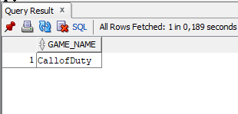

**2) Send the query that SELECTS The Game Name which has a news and that news has a comment which comment_id is “2”.**

SELECT GAME_NAME FROM NEWS WHERE NEWS_ID = (SELECT NEWS_NEWS_ID FROM COMMENTS WHERE COM_ID = 2);

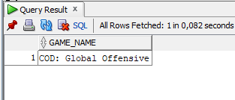

**3)Find game names which words start with “th”.**

SELECT GAME_NAME FROM GAMES WHERE GAME_NAME LIKE 'Th%';

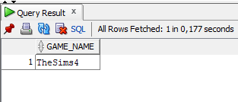

**4)Find game names which words don’t start with “th”.**

SELECT GAME_NAME FROM GAMES WHERE GAME_NAME NOT LIKE 'Th%';

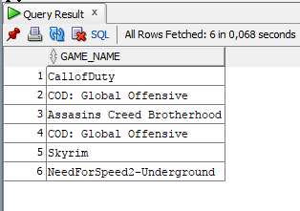

**5)Order the tables by opposite User_ID**

SELECT * FROM USERS ORDER BY USER_ID DESC;

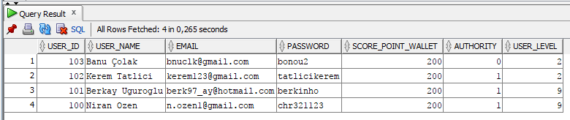

**6)Order the tables first by User_Level than order by User_ID**

SELECT * FROM USERS ORDER BY USER_LEVEL, USER_ID;

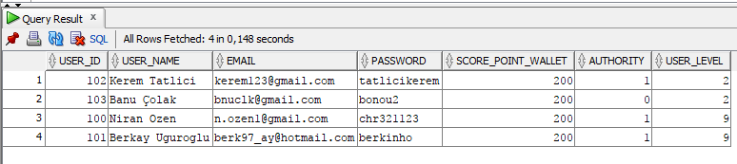

**7)Order the tables first by opposite Game_Name than order by Game_ID**

SELECT * FROM GAMES ORDER BY GAME_NAME DESC, GAME_ID ASC;

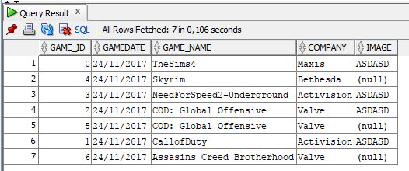

**8)Order the tables by Game_ID but separate that images are null and maket he nulls under the tables.**

UPDATE GAME SET IMAGE =null WHERE GAME_ID > 3;

SELECT * FROM GAMES ORDER BY GAME_ID nulls last;

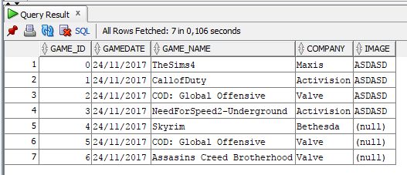

**9) Find Game_Name which Game_ID is maxiumum but Game_ID has been looked from news table**

SELECT GAME_NAME FROM GAMES WHERE GAME_ID = ( SELECT MAX (GAMES_GAME_ID) FROM NEWS);

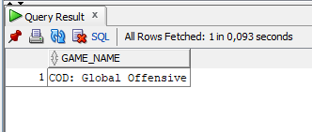

**10)Find LIKE_ID which has been liked comment that has minimum comment_ıd**

SELECT LIKE_ID FROM LIKES WHERE COMMENTS_COM_ID=(SELECT MIN(COM_ID) FROM COMMENTS) ;

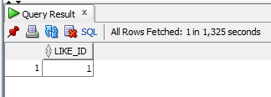

**11)Union COMMENT_DATE and NEWDATE and order by COMMENT_DATE**

SELECT COMMENT_DATE FROM COMMENTS UNION SELECT NEWDATE FROM NEWS ORDER BY COMMENT_DATE;

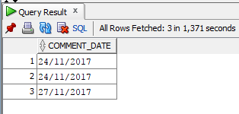

**12)Getting the average of all users level**

SELECT AVG(USER_LEVEL) FROM USERS;

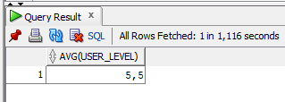

**13)Gather the likes**

SELECT SUM(SITUATION) FROM LIKES;

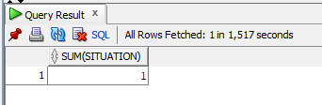

**14)Find users and them information which user_names start with ‘B’**

SELECT * FROM USERS WHERE USER_NAME LIKE 'B%';

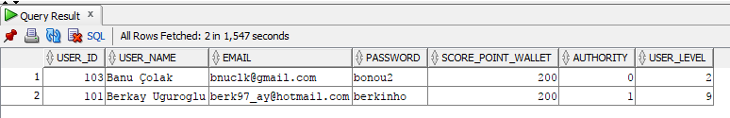

**15)Show games informations which companys valve or maxis.**

SELECT * FROM GAMES WHERE COMPANY IN ('Valve','Maxis');

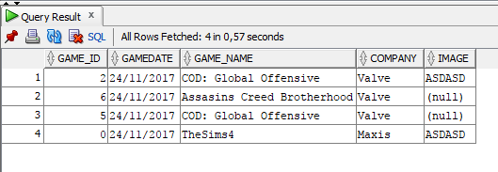

**16)Show games informations which companys not valve or maxis.**

SELECT * FROM GAMES WHERE COMPANY NOT IN ('Valve','Maxis');

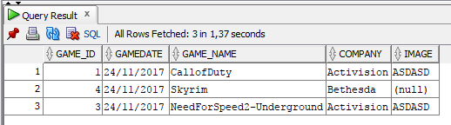

**17)Show users which levels between 1 and 4**

SELECT * FROM USERS WHERE USER_LEVEL BETWEEN 1 AND 4;

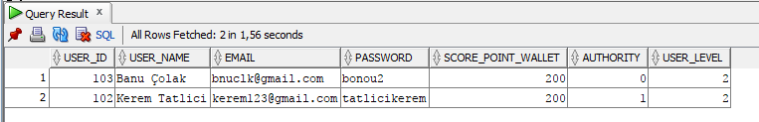

**18)Show users which levels not between 1 and 4**

SELECT * FROM USERS WHERE USER_LEVEL NOT BETWEEN 1 AND 4;

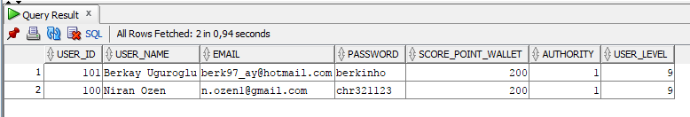

**19)Change the Score_Point_Earning name as salary and Show it on the table**

SELECT SCORE_POINT_EARNING AS SALARY FROM ACTIVITY;

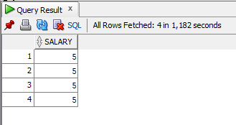

**20)How to create database ?**

Create Database TestDB;

**21)how to drop database?**

Drop Database testDB;

DROP DATABASE databasename;